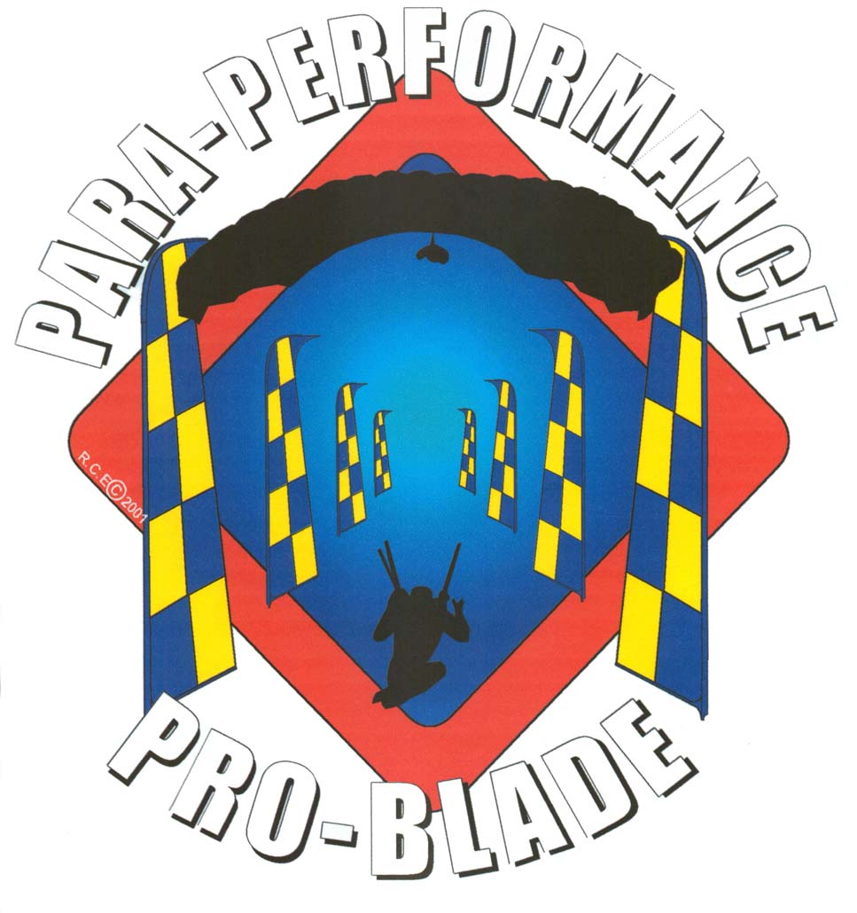

Pro Cup meet

Perris Valley Skydiving

June 7-10, 2001

The Para-Performance Pro Blade Tour proudly presents the “2001 Pro Cup” meet. Canopy pilots from around the world will compete for cash, medals & top positions at the Perris Valley Skydiving swoop park. The PPPB staff has prepared a series of intense Para-Performance Pro Blade courses to challenge the ultimate high performance pilot and his canopy. The Pro Cup will consist of three Pro events and one intermediate. Extreme canopy competitions in speed, accuracy & distance!

General Competition Information

The Para-Performance Pro Blade “ProCup Meet” will take place at Perris Valley Skydiving June 7-10, 2001. The Pro Cup will consist of three, three round events, in which the PPPB has prepared some of the most challenging, competitive and safest canopy courses in the sport. The competition will consist of a speed, accuracy and distance event. There will be no overall winners of combined events at this meet. Each event will be treated like an individual competition with it’s own winners. The top three winners of each event will receive PPPB medals and all first place winners will receive a cash prize. In addition, all pilots competing at PPPB competitions will earn a rank in the speed, accuracy & distance category. This rank will accurately reflect the positions of all the PPPB competitions in which the canopy pilot participates.

Two hot topics within the PPPB association are finalized for the new competition season. #1- The Para-Performance Pro Blade staff will allow a canopy pilot to switch canopies between events. However, switching canopies between rounds of a single event is strictly prohibited. #2- a hard shell helmet is required for all canopy pilots at PPPB competitions. Competitors are free to choose the type of helmet worn (full-face, skate, motoX, ect), but it must have a hard outer surface. Competitors who negotiate a course without a helmet will be issued the lowest possible score for that round. A second helmet violation by a competitor will justify disqualification from that competition.

The PPPB Pro Cup meet in June and the PPPB World Games in November will both include an intermediate event. The intermediate event will take place prior to the Pro events and are required for all new or unclassified canopy pilots requesting a slot as a Pro competitor. Additional information on the events or competitions of the PPPB may be obtained through www.airblades.com or feel free to contact ParaProTour@excite.com

2001 Pro Cup Registration

Name:

Home address:

E-mail address:

Home Drop Zone:

Are you currently registered with the PPPB Tour or Association? Y / N

Are you registering as a Pro or intermediate competitor? Pro/Intermediate

How many Pro canopy competitions have you attended?

Number of jumps: USPA membership #:

Competition canopies & wing loadings:

Which PPPB event interests you the most? Speed/Accuracy/Distance

Exit Weight: Sponsors:

-Pro competitor registration $70 total (three events)
-Intermediate competitor registration $20 total (one event)
Pre-registration is required for all competitors wanting to confirm a Pro slot. A check or money order (payable to: Evolution Canopy Flight School) attached with this registration form should be sent to:

Evolution Canopy Flight School
2091 Goetz Road
Perris, Ca 92570 USA

Competition Outlook

Day 1 (Thursday June 7th)

8:00am… Final registration & check in (video submissions for contest)
8:30am… Competition briefing for all competitors (MANDATORY)
9:30am… Intermediate competition
12:00pm until dark… Official practice day for Pro competitors.
Don’t forget your helmets for the competition!

Day 2 (Friday June 8th)

7:30am…Course review & safety briefing
8:00am until complete…Pro Speed event (three rounds)
Sunset…Speed scores posted on main competition board, video display on big screen Friday night in the bomb shelter.

Day 3 (Saturday June 9th)

7:30am…Course review & safety briefing
8:00am…Pro Accuracy event (three rounds)
2:00pm…Pro Distance event (three rounds)
Sunset…Saturday night party in the Bomb shelter & swoop video contest! Bring your most epic video of yourself or friends ripping it up! The best single swoop caught on tape takes home the medal!

Day 4 (Sunday June 10th)

Weather day for all incomplete events
11:59am (approximate) … award ceremony at the bomb shelter.

Competition Training Camp
($20 a day!)

The Para-Performance Pro Blade staff will hold a competition training camp at Perris Valley Skydiving one week prior to the Pro Cup competition. From June 1-6th the staff will provide a complete training package. The cost of the training camp will be $20 a day plus the cost of your hop & pops. The PPPB will provide a variety of Airblade courses and video services of your every swoop over the pond. Coaches will be available for debrief and all other related discussions. In addition, the Evolution Canopy Flight School will provide instruction on basic aerodynamics, design parameters, flight environment, high performance flight training & more!

All canopy pilots may attend on any day of the training camp. Intermediate canopy pilots who successfully complete (and qualify) three or more days of the training camp may be considered for an open slot (if available) in a Pro event. Come on out and build your skills during the PPPB high performance canopy training camp located at Perris Valley’s swoop park!

Swoop Video Contest

The PPPB Pro Cup meet will hold a swoop video contest at the bomb shelter Saturday night. Dust off those tapes! Its time to dig up your most epic footage of yourself or friends ripping it up! Videos entries will be reviewed on the big screen TV inside the bomb shelter as all your friends & competitors look on. After a full peer review, someone will walk away with a Para-Performance medal & prize!

Contest guidelines & Rules:

-Each competitor may submit footage of two swoops for review. Footage must be submitted to the PPPB staff no later than check-in on day 1 (June 7, 2001) of the meet. Footage submitted after final registration will not be accepted. To qualify, the footage must be of yourself or someone you filmed doing the swooping.

#1- Footage must be presented on a normal VHS tape.

#2- Footage may be edited with music or effects. Footage may be sped up or slowed down but the tape must have a full speed version of that same run.

#3- Footage may contain crashes but video of swoops that result in pilot injury are prohibited.

