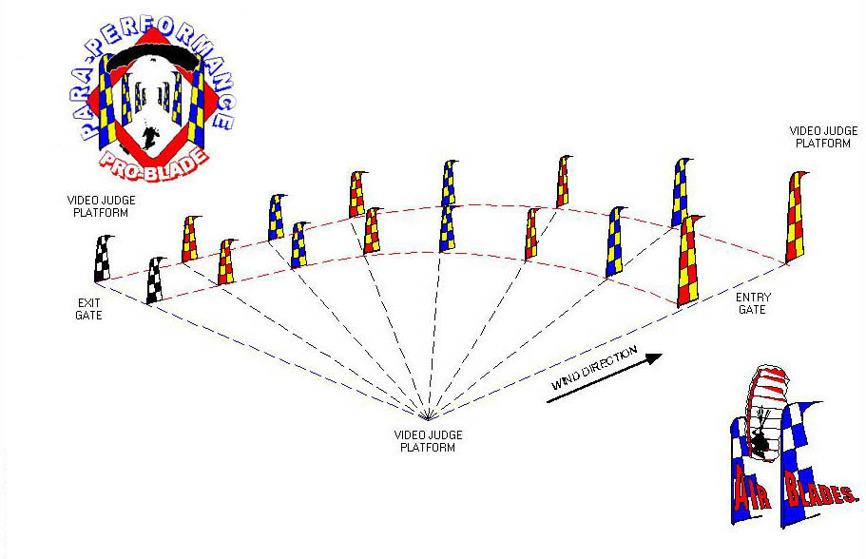
THE SPEED COURSE: The speed course (also over the pond) will be a minimum of 180 feet in length (with a curve) and consist of at least eight Airblade gates. Competitors must score the entry gate (To score a gate: some part of the pilot’s body must pass below the imaginary line connecting the top of the Airblade gates) and then fly through the course, to the exit gate, in the fastest time possible. A penalty of five seconds will be added to a competitor’s time for each contact (body or canopy) made with an Airblade while negotiating the course. A competitor may be penalized for a blade strike of the exit gate even if their time has stopped. Competitors who come up short in the course will be allowed to “kite” their canopy through to the exit gate for a timed run, but the canopy must not make contact with the surface and blade strikes still apply.

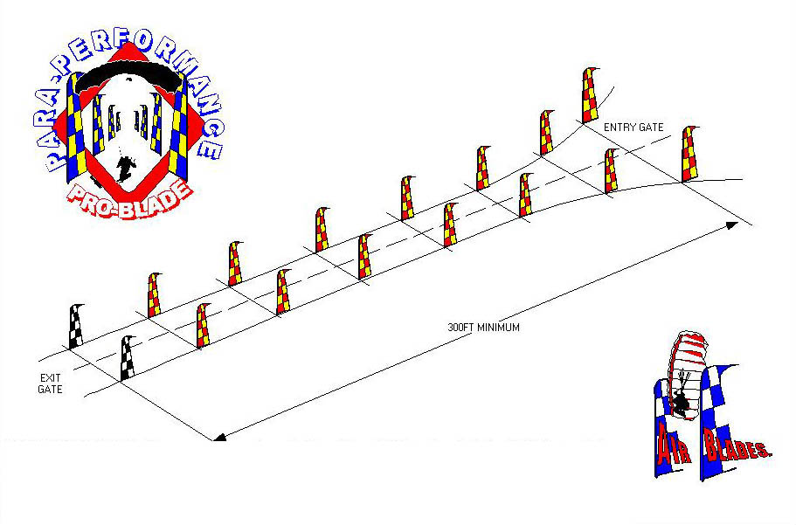
THE DISTANCE COURSE: The distance course (also over the pond) will be a minimum of 300 feet in length and consist of at least eight Airblade gates. Unlike distance events at previous competitions, the PPPB Pro Cup meet will require competitors to touch the surface (water) prior to entering the course at the first gate. Competitors are not required to drag their feet through the distance course. Instead, competitors should only make a brief, light contact with the water signaling the start of their run. This distance competition has been formatted to challenge the competitor to a true horizontal swoop across the surface instead of initiating the run 20 feet up in the entry gate. A competitor’s run, measured in feet, will be their score for each round. The total distance of all three rounds will be the competitor’s overall score. Even though there are no blade strike penalties for this event all competitors are required to stay within the boundaries of the course (defined by Airblades) in order to receive a score.

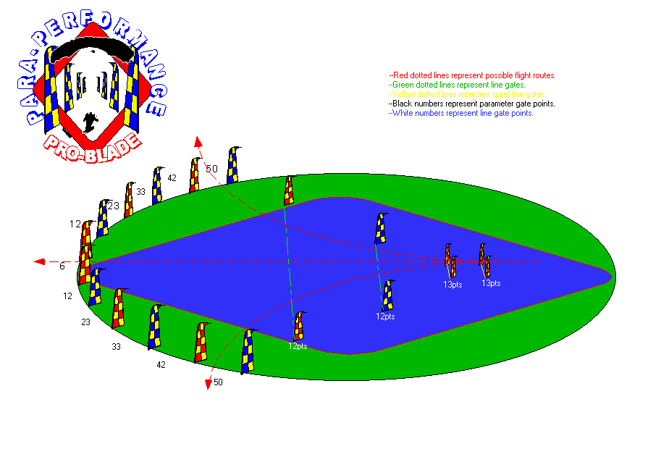THE ACCURACY COURSE: The accuracy course consist of a “quad” entry gate (four-4 ft mini Airblades), two line gates and eleven parameter gates. Competitors are required to score the quad entry gates and then fly through the line gates (floating on the pond) to the parameter gate of their choice. The parameter gates are arranged so that competitors may carve left or right and still have the opportunity to accumulate the same amount of points. The center (neutral) parameter gate is worth 6 points and the five gates on each side of it are worth 12, 23, 33, 42 & 50 points, in that order. A competitor’s body must pass or “score” the parameter gate in which they are attempting to negotiate prior to their first point of contact with the ground (not the water) in order to receive points for that gate. Competitors may also accumulate points for dragging one or both feet, on the water, through the quad & line gates floating on the pond. Competitors will have 5 points deducted from their score for each contact they make (body or canopy) with any Airblade in the course. Competitors who score all the quad & line gates on the pond and successfully score the outer most parameter gate (50pts), with no penalties, will be given the maximum of 100 points for that round.

